Yetminster Health Centre
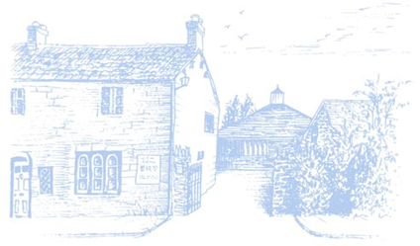
Patient Participation Group
Minutes
23rd March 2022

Present:
CH – Chris Hardy
AB – Angela Bowring
GF – Gill Foott
MP – Marcus Pawson
LA – Layla Ansar

 |  | Action
1. | Apologies
 | None
2. | Minutes from Last Meeting
 | Agreed
3. | Matters Arising
 | - Two potential patients have been contacted by CH who have expressed an interest in becoming PPG virtual members. A further expression of interest will be followed up | CH
 | - CH has signed the Terms of Reference and Code of Conduct and will forward to MP. | CH
 | - Surgery Tour and ‘Meeting the Team’ will take place once Covid levels have reduced. To be carried forward. | LA
 | - Surgery demographics shared. Document to be forwarded to PPG members. COMPLETED  - Key points noted - a rural demographic of older people and 10 -19 years old due to the addition of Sherborne School Boys.  - Ethnicity 76% British White.  - Other priorities and local needs will be identified over the coming months | MP
 | - Newsletter – agenda item 5.
 | - Surgery staff meeting feedback to be carried forward. | MP
4. | CCG Support
 | GF gave an overview of her role :-  - Supports North Dorset GPs and provides guidance and advise to PPG’s.  - To forward PPG support page link enabling access to downloadable templates.  - PPG Chair/Representatives Network meetings held on alternative months.  - Regular webinars held with the Conference to be resurrected in 2023.  - Has contact with a number of voluntary groups. | GF
 | Nominated Primary Care Representative to be identified. | GF
 | A number of options explored to raise PPG profile.  GF to send ‘banners’ for Yetminster Jubilee Celebrations. | GF
 | GF offered to provide a written summary on the role of PPG’s as part of surgery information sharing.  CH noted that each village required different information options apart from online information. | GF
5. | Newsletter
 | - To focus newsletter from a Surgery perspective.
 | - Frequency – Quarterly. First publication to aim for Easter. | CH/AB
 | - Surgery to forward dates and content items for first publication. COMPLETED | MP/LA
 | Publication and distribution options discussed. Print costs not currently available, although inhouse distribution can be considered in small numbers.  CH to approach Wiggle Valley magazine and explore printing costs. | CH
5. | AOB
 | Outside support/advisors will attend PPG meetings once the PPG is well established.
6. | Next Meeting
 | 27th April 2022 @ 10.00am.  Video or face to face to be confirmed. | LA

